Ideation Phase
Define the Problem Statements
Date | 19 Jul 2026
Team ID
Project Name | AI-powered Job Recruitment & Candidate Management System
Maximum Marks | 2 Marks

Customer Problem Statement

Problem Statement (PS) | I am (Customer) | I'm trying to | But | Because | Which makes me feel
PS-1 | I am a Recruiter. | I'm trying to manage job openings, screen candidates, schedule interviews, and track the recruitment process efficiently. | But the recruitment process is mostly manual, time-consuming, and difficult to manage when handling many applicants. | Because candidate information is scattered across emails, spreadsheets, and documents, making it difficult to monitor progress and collaborate with hiring managers. | Frustrated, overwhelmed, and concerned about missing qualified candidates or delaying the hiring process.
PS-2 | I am a Job Applicant (Candidate). | I'm trying to apply for jobs and stay informed about my application status throughout the recruitment process. | But I receive limited updates and experience long waiting periods without knowing the progress of my application. | Because there is no centralized system to provide timely communication, interview schedules, or application status updates. | Anxious, uncertain, and dissatisfied with the overall recruitment experience.

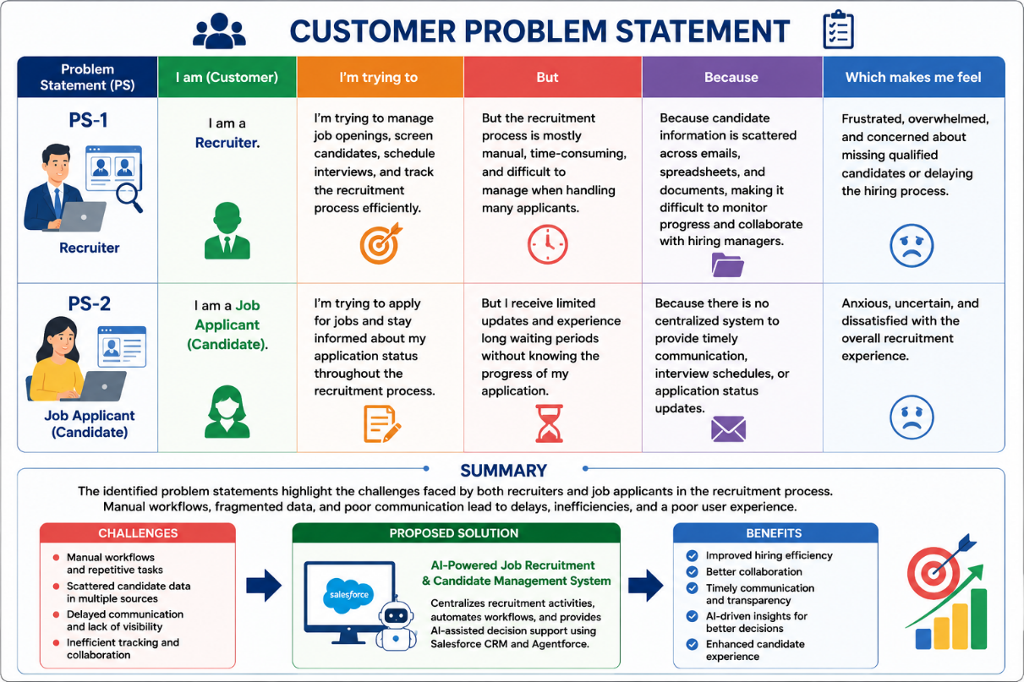

Summary
The identified problem statements highlight the challenges faced by both recruiters and job applicants in the recruitment process. Manual workflows, fragmented data, and poor communication lead to delays, inefficiencies, and a poor user experience. The proposed AI-Powered Job Recruitment & Candidate Management System addresses these challenges by centralizing recruitment activities, automating workflows, and providing AI-assisted decision support to improve hiring efficiency and candidate satisfaction.

